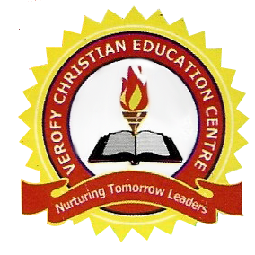  
[

VEROFY CHRISTIAN EDUCATION CENTRE

14A, PZ ROAD, OFF SAPELE ROAD, BENIN CITY.

3RD TERM HOLIDAY PROJECT 2020/2021 SESSION.

Nursery 2

|  |  |
| --- | --- |
| **Number Work** | 1. Re-arrange the number in order of smallest to the biggest.  152 157 159 151 156 153 160 158 154  1b. 194 193 197 199 191 198 192 200 195 196  (2) What is division? (2b) 8 ÷ 2 =  (3) Match each picture with the correct number.  2  6  1  3  4  5 |
| Letter Work | (1) What are rhyming word? (1b) Complete the following rhyming words:  Bat, Cat ____, _____  (2) Write 10 four letter words with vowel a, e, o, i, u (3) What is a noun? |
| Social studies | (1i) What is child abuse? (1ii) children should go to and study.  (2i) What is drug abuse? (2ii) List 2 effects of drug abuse.  (3) What is family? |
| Basic Science | (1) Write the babies of these animal  Lion  Cow  Giraffe  (2) What is an accident? (2ii) An accident victim can be given ______ treatment before going to hospital  (3) Write 3 objects in and around the school you know. |
| C. R. S | (1) Jesus resurrected from the death on the _____ day.  (2) ____ Cane upon the disciples (3) Write 5 things created by God. |
| Hand Writing | Rewrite the following sentences on five lines each.  (i) I Love Jesus  (ii)  (iii)  (iv)  (v)  (2) He is My Friend  (i)  (ii)  (iii)  (iv) (v) |
| Health Habit | (1i) What is water? (ii) Write 5 sources of water.  (2) What is air pollution? (2ii) ______ and ______ are the causes of air pollution (3) Write 5 parts of the body you know |
| C. C. A | (1) With the aid of a cardboard paper, draw and colour (i) A means of transportation by air (ii) A means of transportation on land. (iii) A means of transportation by water (2) What is music?  (3) List 3 musical instrument you know. |