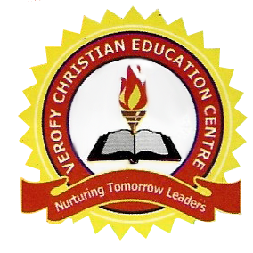

[

VEROFY CHRISTIAN EDUCATION CENTRE

14A, PZ ROAD, OFF SAPELE ROAD, BENIN CITY.

3RD TERM HOLIDAY PROJECT 2020/2021 SESSION.

Nursery 1

|  |  |
| --- | --- |
| Subject | Text of Questions |
| Number Work | (1) Count and write 1—100,  (2) Count the objects correctly = =  (3) 1 ___ 3 ____ 5 ____ 7 ____. |
| Letter Work. | (1) Read and write capital letter A—Z  (2) Read and write small letter a—z  (3) Write any 6 two letter words |
| Science | (1) What is first aid? (2) List the five sense organs  (3) List 4 examples of wild animals |
| Social Habit | (1) What is emotion? (2) What is music?  (3) On a white cardboard paper, draw 2 music instrument and colour it. |
| Health Habit | (1) What is table manner? (2) What is water?  (3) List 4 uses of water. |
| C. R. S | (1) What was the gift given to Jesus by the three wise men?  (2) Who is our provider? (3) Jesus feed the multitude with ______ |
| Hand Writing | (1) Trace and copy these letters.    ____ ____ ____  ____ ____ ____  ____ ____ _____ |
| C. C. A | (1) Identify and write the names of these shapes    (2) List _____ _____ _____ _____  (3) Draw and colour these object (i) Car (ii) Bag. |
| Phonetics | (1) Write the letter name for letter  (i) A (ii) B (iii) C (iv) G (v) H (vi) I (vii) O  (2) Match the following letters to the correct sound  (i) C /˄/  (ii) O /kwa/  (iii) Q /k/  (iv) U /ɒ/ |