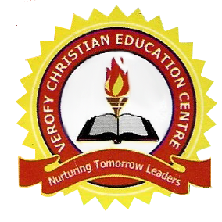

VEROFY CHRISTIAN EDUCATION CENTRE

14A, PZ ROAD, OFF SAPELE ROAD, BENIN CITY.

Third term holiday assignment

Class: JSS 3

|  |  |  |
| --- | --- | --- |
| NO. | SUBJECT | ASSIGNMENT |
| 1. | BST | 1. Explain database with its types (2) Explain elements and list first 20 elements |
| 2. | C.C.A. | 1a. What is embroidery? (b) List four materials used in embroidery (2a) What is botik? (b) State four materials and tools for batik |
| 3. | Maths | 1. Change the following base ten numbers to base five.  (a) 256 (b) 99  2. Convert the following to base ten. (a) 301four (b) 616seven (c) 11110two |
| 4. | English Language | 1. What is poetry, drama and literature? 2. List 3 responsibilities of the government. (3) Write the minutes of your club held recently in your school. (4) Using a table illustrate the differences between narrative essay and expository essay. |
| 5. | National Value  Social Studies | 1. Briefly trace the History of social studies and mention the first school it was taught in Nigeria. 2a. What are conflicts? (b) Suggest three ways by which conflicts can be resolved. |
|  | Civic Education | 1a. State three values of civic education (b) State four reasons why civic education was introduced in schools |
| 6. | Prevocational  Home Economics | 1a. Explain consumers redress. (b) State three procedures for seeking redress. |
|  | Agric. Science | 1a. Define packaging (b) State four criteria for packaging |
| 7. | Business Studies | 1a. Define office procedures (b) State three importance of office procedures |
| 8. | C.R.S. | 1a. Who is the Holy Spirit? (b) State four importance of the Holy spirit. |
| 9. | History | Describe the early contacts of Europeans with Nigeria. |

10. Edo Language - Ye ikpemwe nay a kun ifiemwe obo rue

1. Ohanmwe

2. Nokpere

3. Evbare

4. Vbuavbua

5. Iye ere

6. Owa Isinmwiegbe

7. Omobo

8. Ukpo hoho gbalaka

9. Evbene

10. khian